**Library (and more!) Resources for Genealogy. December 12, 2022**

Free genealogy forms for printing: <https://www.ancestry.com/cs/charts-and-forms>

Genealogy Links: <https://ccld.lib.ny.us/genealogy-links/>

**FREE SITES:**

FamilySearch: <https://www.familysearch.org/en/>

Wikitree<https://www.wikitree.com/>

FamilySearchWiki: <https://www.familysearch.org/en/wiki/Main_Page>

CyndisList: <https://www.cyndislist.com/us/>

Internet Archive Genealogy Portal: <https://archive.org/details/genealogy>

**Newspaper Sites**

Library of Congress Chronicling America: <https://chroniclingamerica.loc.gov/>

NYS Historic Newspapers: <https://nyshistoricnewspapers.org/>

Elephind: <https://elephind.com/>

Fulton History: <https://fultonhistory.com/>

**Digitized Books Online**

Google Books: <https://books.google.com/>

Family Search: <https://www.familysearch.org/>

**Library Catalogs Worldwide**

Worldcat: <https://www.worldcat.org/>

**NYS vital Statistics**

NYS Death Indexes: [**https://health.data.ny.gov/**](https://health.data.ny.gov/)

NYS adoption Information: [Adoption Information Registry](https://www.health.ny.gov/vital_records/adoption.htm)

**NYC Vital Records:** [**https://a860-historicalvitalrecords.nyc.gov/digital-vital-records**](https://a860-historicalvitalrecords.nyc.gov/digital-vital-records)

**Paid Sites with Free Data Sets.**

Ancestry.com New York: free New York records for NY residents

<http://www.archives.nysed.gov/research/how-to-video-ancestry>

**Contact**

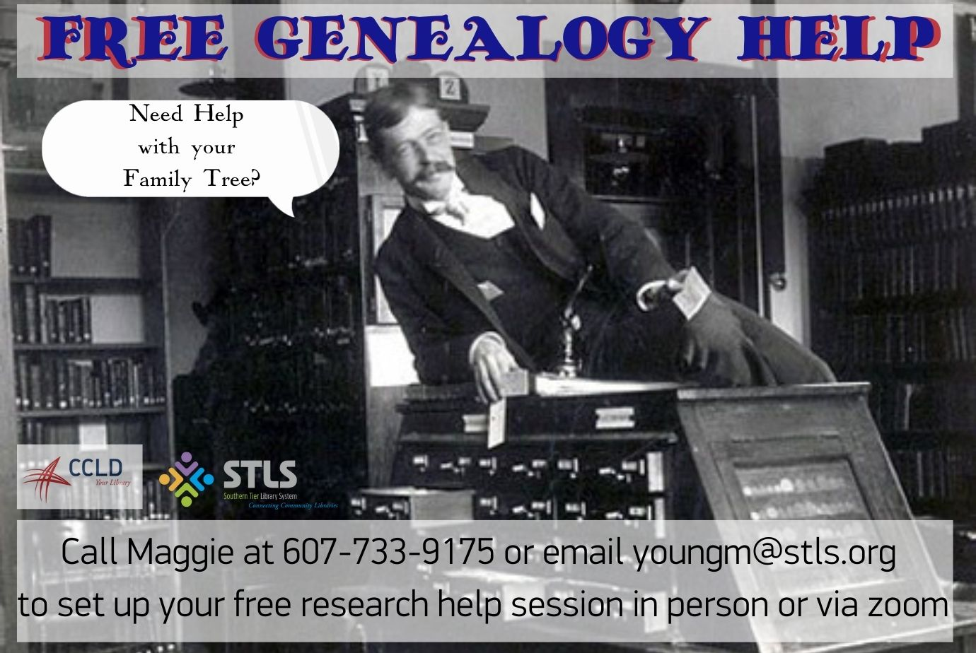

Maggie Young, CCLD Genealogy & Local History Librarian [youngm@stls.org](mailto:youngm@stls.org)

607-733-8603 (office), 607-733-9175 (reference desk)

Website: <https://ccld.lib.ny.us/> (for event calendar, click EVENTS)

<https://www.facebook.com/elmiragenealogyhistory>

<https://www.instagram.com/ccldgenealogy/>